Query OF SQL for KPI and Chart Required

KPI

1. Total Revenue

* select sum(total_price) as Total_Revenue from pizza_sales

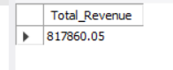

1. Average Order Value

* select sum(total_price) / count (distinct order_id) as Average_order_value from pizza_sales;

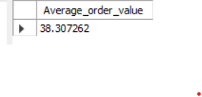

1. Total Pizzas Sold

* select sum(quantity) as Total_pizza_sold from pizza_sales;



1. Total Orders

* select count (distinct order_id) as Total_order from pizza_sales;

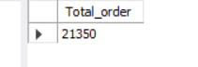

1. Average Pizzas Per Order

* select sum(quantity) / count (distinct order_id) as Average_pizza_per_order from pizza_sales;

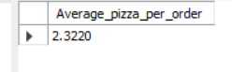

VISUALIZATION

1. Hourly trend for Total Orders

* select hour(order_time) as Hours, count (distinct order_id) as Total_Order from pizza_sales

group by Hours

order by Hours;

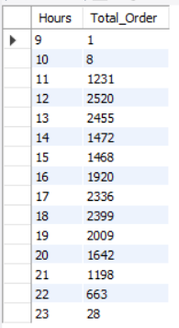

1. Daily trend for Total Orders

* select dayname(order_date) as Weekdays, count (distinct order_id) as Total_order from pizza_sales

group by dayname(order_date);

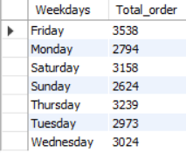

1. Monthly trend for Total Orders

* select monthname(order_date) as Month_Name, count (distinct order_id) as Total_sales

from pizza_sales

group by monthname(order_date);

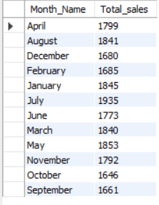

1. % of Sales by Pizza Category

* select pizza_category,sum(total_price) * 100 / (select sum(total_price) from pizza_sales) as sales_per from pizza_sales

group by pizza_category

order by sales_per desc;

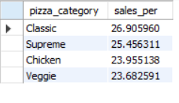

1. % of sales by Pizza Size

* select pizza_size , cast(sum(total_price) * 100 / (select sum(total_price) from pizza_sales) as decimal(10,2)) as sales_per from pizza_sales

group by pizza_size

order by sales_per desc;

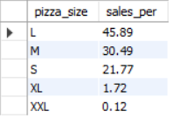

1. Total Pizzas Sold by Pizza Category

* select pizza_category , sum(quantity) as pizza_sold from pizza_sales

group by pizza_category

order by pizza_sold desc;

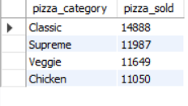

1. Top 5 Pizza by Revenue

* select pizza_name ,sum(total_price) as Revenue from pizza_sales

group by pizza_name

order by Revenue desc limit 5;

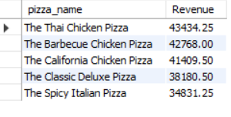

1. Top 5 Pizza by Quantity

* select pizza_name ,sum(quantity) as Quantity from pizza_sales

group by pizza_name

order by Quantity desc limit 5;

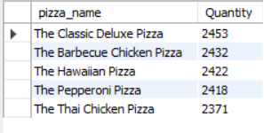

1. Top 5 Pizza by Total Orders

* select pizza_name ,count(distinct order_id) as Total_orders from pizza_sales

group by pizza_name

order by Total_orders desc limit 5;

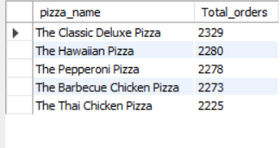

1. Bottom 5 Pizza by Revenue

* select pizza_name ,sum(total_price) as Revenue from pizza_sales

group by pizza_name

order by Revenue limit 5;

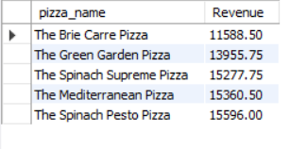

1. Bottom 5 Pizza by Quantity

* select pizza_name ,sum(quantity) as Quantity from pizza_sales

group by pizza_name

order by Quantity limit 5;

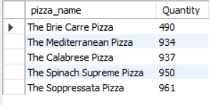

1. Bottom 5 Pizza by Total Orders

* select pizza_name ,count(distinct order_id) as Total_orders from pizza_sales

group by pizza_name

order by Total_orders limit 5;

